1. **Aim:** Developing State Chart diagram for Railway Ticket Reservation.

[Statechart diagrams,](https://www.smartdraw.com/state-diagram/) now known as state machine diagrams and state diagrams describe the dynamic behavior of a system in response to external stimuli. State diagrams are especially useful in modeling reactive objects whose states are triggered by specific events. The following steps are used to develop state chart diagram.

**Step 1 - Define states:** Specify possible, meaningful conditions or situations an object might bein during its life time in a system.

**Step 2 - Describe states:** Tell others more in detail about what those states are withdocumentation for future reference.

**Step 3 - Draw transitions:** Draw directed lines to depict changes from one state to another.

**Step 4 - Define transition triggers:** Clarify what events kick off the transitions.

**Step 5 - Define guard conditions:** Place constraints that need to be met before a transitionactually takes place - making a transition conditional.

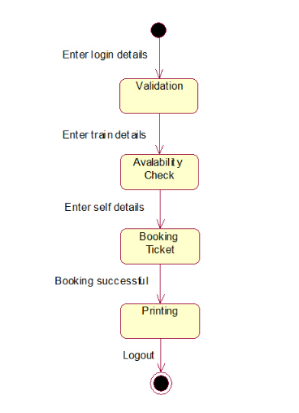

1. **Aim:** Developing Activity Diagram for Railway Ticket Reservation.

[Activity diagrams](https://www.smartdraw.com/activity-diagram/) illustrate the dynamic nature of a system by modeling the flow of control from activity to activity. An activity represents an operation on some class in the system that results in a change in the state of the system. Typically, activity diagrams are used to model workflow or business processes and internal operation. Before drawing an activity diagram, we should identify the following elements.

Activities Association Conditions Constraints

Once the above-mentioned parameters are identified, we need to make a layout of the entire flow. This layout is then transformed into an activity diagram.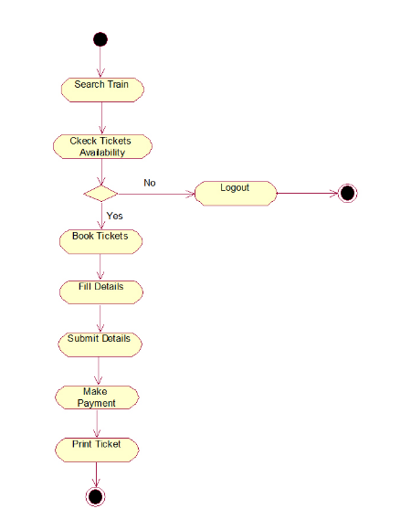

1. **Aim:** Developing Deployment Diagram for Railway Ticket Reservation.

Deployment diagrams depict the physical resources in a system, including nodes, components, and connections.

The following steps are used to develop deployment diagram.

1. Identify the nodes.
2. Represent the relationships in between the nodes.

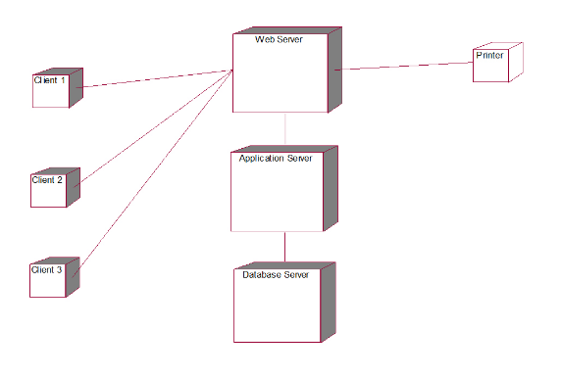

**Result:** The Design was successfully completed.